CLOUD COMPUTING LAB 6

EXPERIMENT 6: Familiarization and Usage of Cloud Services Using AWS and OpenSource Cloud Tools
Aim: To become familiar with different cloud services and perform basic cloud operations using Amazon Web Services (AWS), Ubuntu Linux, Oracle VirtualBox and AWS Command Line Interface (CLI).
The experiment can be divided into four practical tasks.
Task | What needs to be done? | How to demonstrate?
1. Virtual Machine  Setup | Install Ubuntu using VirtualBox and execute basic Linux commands. | A working Ubuntu virtual machine and terminal output.
2. Cloud Storage | Create an Amazon S3 bucket, upload a file, view it and download it. | Successful file upload and download in AWS S3.
3. Cloud Service  Exploration | Explore IAM, EC2 and VPC through the AWS Console. | Understanding of cloud security, virtual machines and networking.
4. Cloud  Monitoring and  CLI | Explore CloudWatch and execute basic AWS CLI commands. | Service metrics and successful command outputs.

Task 1: VM Setup
Step 1: Create a Virtual Machine
Step 2: Install Ubuntu

Step 3: Update Ubuntu
Open the Ubuntu Terminal and execute: sudo apt update sudo apt upgrade -y

Step 4: Install Basic Utilities
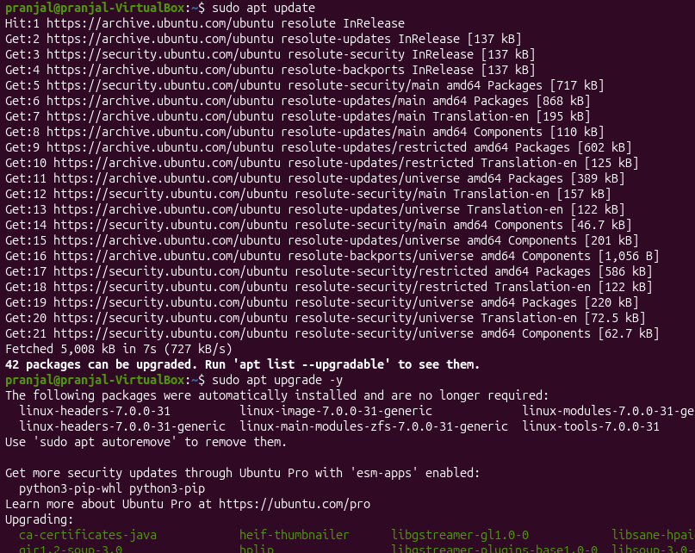
Task 2A: Introduction to AWS Management Console
What is AWS?
Amazon Web Services (AWS) is a cloud computing platform that provides services such as computing, storage, databases, networking, security and monitoring.
AWS allows users to create and manage cloud resources without maintaining physical infrastructure.

Step 1: Access AWS Management Console
- Open a web browser.
- Visit https://console.aws.amazon.com/
- Sign in using an authorised AWS account.
- Explore the AWS Management Console home page.
- Observe the search bar used to locate different AWS services.
Task 2B: Implementation of Cloud Storage Using Amazon S3

Introduction to Amazon S3
Amazon Simple Storage Service (Amazon S3) is an object storage service used to store and retrieve data over the internet.

Step 1: Open Amazon S3
- Log in to the AWS Management Console.
- Search for S3.
- Open Amazon S3.
- Select Create bucket.

Step 2: Create an S3 Bucket
- Enter a globally unique bucket name.
Example:
cse12045-cloud-lab6-student01
- Select the AWS Region.
- Keep Block Public Access enabled.
- Keep default encryption enabled.
- Select Create bucket.
Note: Never make the bucket public for this experiment.
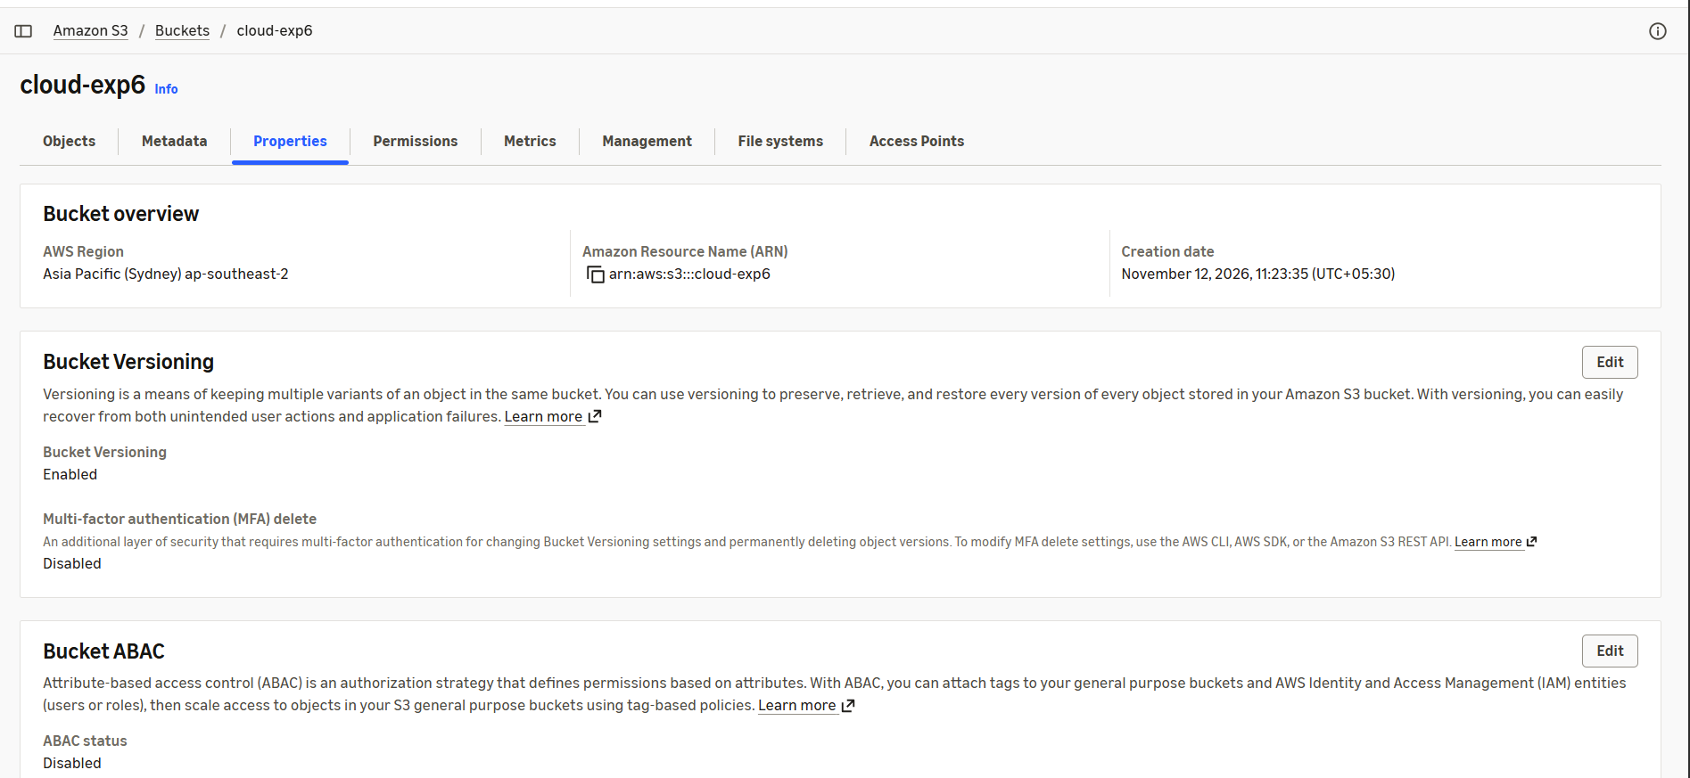

Step 3: Create a Sample File in Ubuntu
Open the Ubuntu Terminal and execute:
mkdir cloud-lab6 cd cloud-lab6 echo "Cloud Computing Lab Experiment 6" > lab-note.txt cat lab-note.txt
Explanation:
- mkdir: Creates a directory.
- cd: Changes the current directory.
- echo: Writes text into a file.
- cat: Displays the contents of a file.

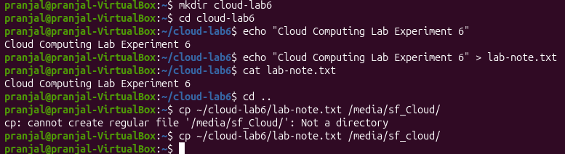
Step 4: Upload a File to S3 1. Open the created S3 bucket.
- Select Upload.
- Click Add files.
- Select lab-note.txt.
- Click Upload.
- Verify that the file appears inside the bucket.
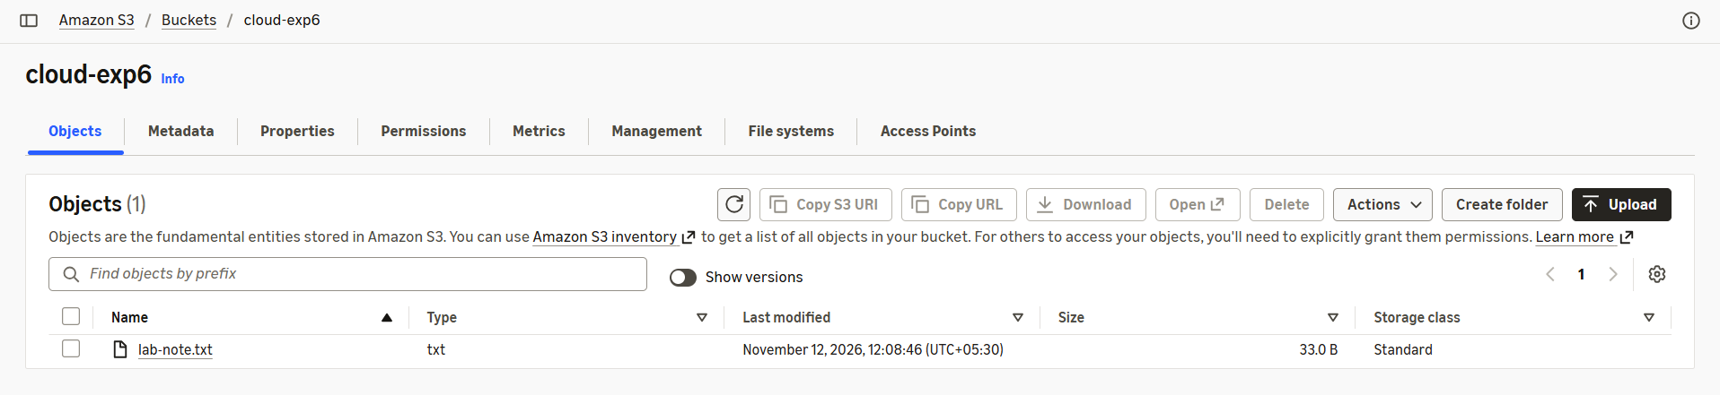
Step 5: Download the File 1. Select the uploaded object.
- Click Download.
- Open the downloaded file.
- Verify that the contents match the original file.
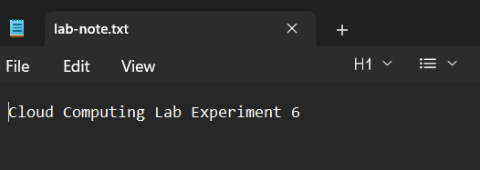

Step 6: Delete the Test Object and Bucket
- Select the uploaded object.
- Choose Delete.
- Confirm deletion.
- Once the bucket is empty, delete the bucket.
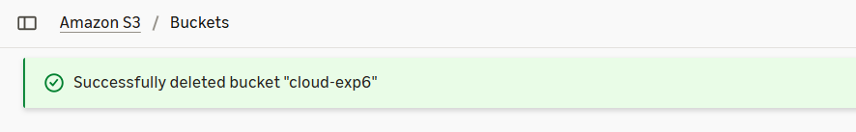
Expected Result: A private S3 bucket should be created successfully, and a sample file should be uploaded, downloaded and deleted.
Task 3A: Identity and Access Management Using AWS IAM

Introduction to IAM
AWS Identity and Access Management (IAM) is a service used to manage access to AWS resources securely. It controls who can access AWS services and what actions they can perform.

Step 1: Open IAM
- Log in to AWS Management Console.
- Search for IAM.
- Open the IAM Dashboard.
- Explore the Users, Groups, Roles and Policies sections.

Step 2: Understand IAM Policies
An IAM policy defines which actions are allowed or denied for a particular AWS resource.
Example of a basic IAM policy structure:
{
"Version": "2012-10-17",
"Statement": [
{
"Effect": "Allow",
"Action": [
"s3:ListBucket"
],
"Resource": "arn:aws:s3:::example-bucket"
}
]
}
Explanation:
- Version: Specifies the policy language version.
- Effect: Specifies whether an action is allowed or denied.
- Action: Specifies the AWS operation.
- Resource: Specifies the AWS resource to which the permission applies.
This is an illustrative policy that permits listing the contents of the specified bucket. It does not grant permission to upload or download objects.

Step 3: Understand the Principle of Least Privilege
The principle of least privilege means that a user should receive only the minimum permissions required to perform their assigned tasks.
Safety Note: This is primarily an observation activity. Do not create users, generate access keys or change policies in a shared institutional AWS account without instructor approval.
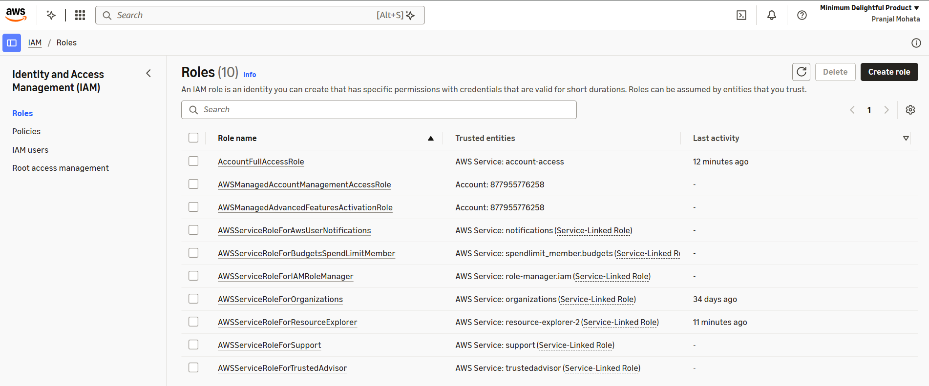
Task 3B: Virtual Machine Provisioning Using Amazon EC2

Introduction to Amazon EC2
Amazon Elastic Compute Cloud (EC2) is a cloud computing service that provides virtual servers.
An EC2 instance acts like a virtual machine hosted on AWS infrastructure.

Step 1: Open EC2
- Log in to AWS Management Console.
- Search for EC2.
- Open the EC2 Dashboard.
- Explore the Instances section.

Step 2: Explore the Instance Launch Process
- Select Launch Instance.
- Enter an instance name.
- Explore the available Amazon Machine Images.
- Observe the available instance types.
- Explore the key pair configuration.
- Observe the network and security-group settings.
- Review the storage configuration.
For this experiment, you may stop at the review stage without launching an instance.

Optional Practical Activity: Launch an EC2 Instance
Only perform this activity if the instructor has approved it and the account's current Free Tier offer explicitly covers the selected configuration.
- Select an eligible Linux AMI.
- Select an instance type eligible under the account's current offer.
- Configure minimum required storage.
- Configure a key pair.
- Configure a security group with only the required access.
- Launch the instance.
- Observe its instance ID and state.
- Terminate the instance after the demonstration.
- Verify that no unwanted storage volumes, snapshots or public IP resources remain.
Important: Do not assume that every EC2 instance is free. Charges can depend on instance type, Region, operating system, storage and account eligibility.
Expected Result: Students should understand the process of creating and managing a cloudbased virtual machine.
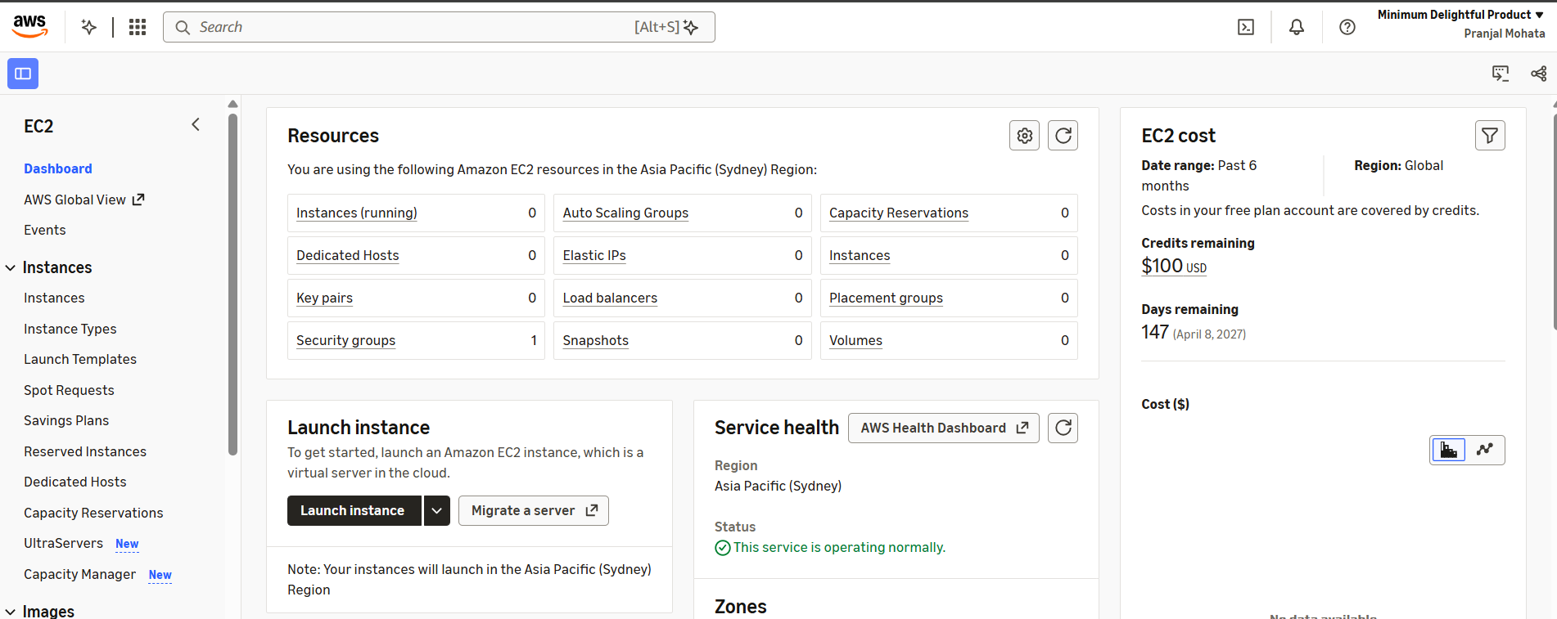
Task 4A: Virtual Networking Using Amazon VPC

Introduction to Amazon VPC
Amazon Virtual Private Cloud (VPC) allows users to create a logically isolated virtual network within AWS.
It provides control over IP address ranges, subnets, routing and network security.

Step 1: Open Amazon VPC
- Open the AWS Management Console.
- Search for VPC.
- Open the VPC Dashboard.
- Explore the Your VPCs section.

Step 2: Explore VPC Components
- Open the Subnets section.
- Observe the available subnets.
- Open Route Tables.
- Identify the associated VPC.
- Explore Internet Gateways.
- Open Security Groups.
- Observe the inbound and outbound rules.

Step 3: Understand Network Communication
A typical cloud network architecture may contain:
A VPC
A public subnet
A private subnet
An internet gateway
Route tables
Security groups
A public subnet can provide internet connectivity when its routing and security configuration allow it. A private subnet generally does not have a direct route to an internet gateway.
Expected Result: Students should understand the basic architecture of AWS virtual networking and identify the different VPC components.
Note: Do not modify or delete default VPC resources during this exercise.
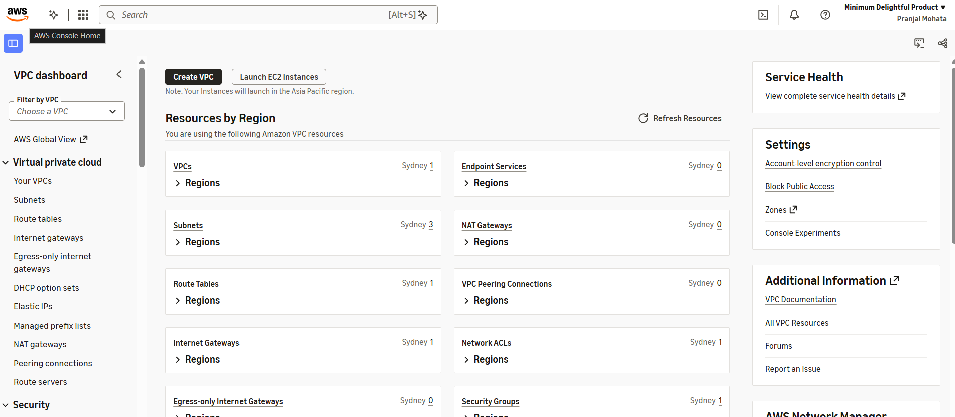
Task 3D: Cloud Monitoring Using Amazon CloudWatch

Introduction to CloudWatch
Amazon CloudWatch is a monitoring and observability service used to monitor AWS resources and applications.
It collects and displays metrics, logs and other monitoring information.

Step 1: Open CloudWatch
- Log in to AWS Management Console.
- Search for CloudWatch.
- Open the CloudWatch Dashboard.

Step 2: Explore Metrics
- Open the Metrics section.
- Explore the available AWS service metrics.
- Identify how metrics are organised by service.
- Observe the different metric dimensions.
For example, EC2 instances can provide CPU utilisation metrics.

Step 3: Explore CloudWatch Alarms
- Open the Alarms section.
- Observe the option to create an alarm.
- Understand how a metric is selected.
- Observe how a threshold can be configured.
- Understand how an alarm can change its state when a threshold condition is met.
Example: An alarm can be configured to notify an administrator when CPU utilisation exceeds a specified threshold for a defined period.
Expected Result: Students should understand the role of CloudWatch in monitoring cloud resources and detecting performance-related issues.
Note: Avoid creating unnecessary dashboards, log groups, alarms or other resources without checking applicable charges.
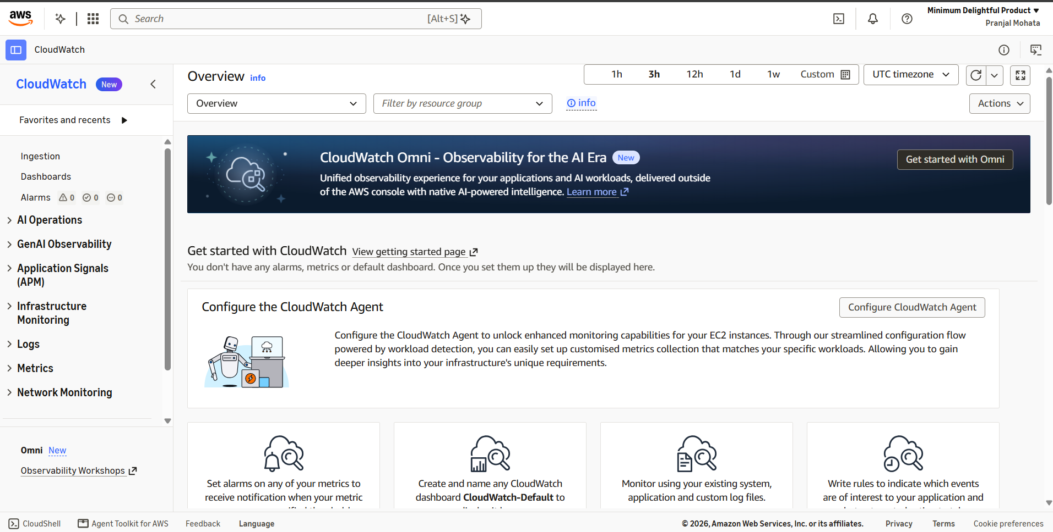

Task 4B: Basic AWS Operations Using AWS CLI

Introduction to AWS CLI
AWS Command Line Interface (CLI) is a tool that allows users to interact with AWS services through terminal commands.
Instead of using the graphical AWS Management Console, users can execute commands to manage cloud resources.

Step 1: Open AWS CloudShell
- Log in to AWS Management Console.
- Locate the CloudShell icon.
- Open CloudShell.
- Wait for the command-line environment to initialise.
CloudShell provides a browser-based terminal connected to the authenticated AWS account.
Alternatively, AWS CLI can be installed in Ubuntu using the official AWS installation instructions.

Step 2: Verify AWS CLI Installation
For Ubuntu installations:
aws --version
Explanation: Displays the installed AWS CLI version. Step 3: Verify AWS Account Identity aws sts get-caller-identity
Explanation: Displays information about the identity associated with the current AWS credentials.
The output includes account and caller information. Avoid sharing sensitive account details in public reports.

Step 4: List Available S3 Buckets aws s3 ls
Explanation: Lists the S3 buckets accessible to the current identity.

Step 5: Create a Local File mkdir cloud-lab6-cli cd cloud-lab6-cli echo "AWS CLI Cloud Storage Test" > sample.txt Step 6: Upload the File to S3 aws s3 cp sample.txt s3://YOUR-BUCKET-NAME/sample.txt
Replace YOUR-BUCKET-NAME with the name of the bucket created in Part C.
Explanation: Uploads the local file to the specified S3 bucket. Step 7: List Objects in the Bucket aws s3 ls s3://YOUR-BUCKET-NAME/
Explanation: Displays the objects stored inside the specified S3 bucket. Step 8: Download the File aws s3 cp s3://YOUR-BUCKET-NAME/sample.txt downloaded.txt
Explanation: Downloads the specified S3 object to the local system. Step 9: Verify the Downloaded File cat downloaded.txt
Expected Result: The content of the downloaded file should match the original file. Step 10: Delete the Test Object aws s3 rm s3://YOUR-BUCKET-NAME/sample.txt
Explanation: Deletes the specified object from the S3 bucket.
Important: Use only authorised temporary credentials or an approved CloudShell session. Never place root credentials, secret access keys or private keys in source code, screenshots or reports.
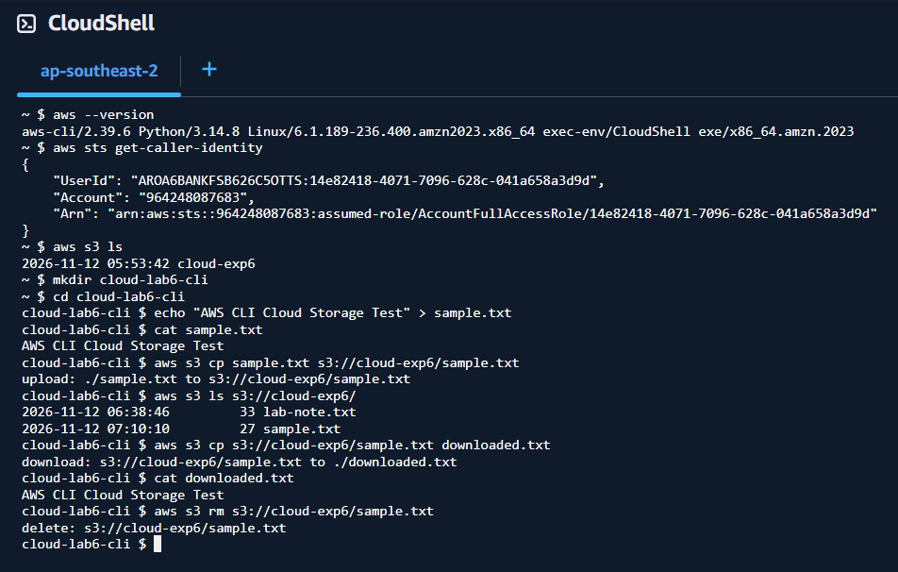

Precautions and AWS Cost Management
Important

AWS Free Tier does not mean every AWS service and configuration is automatically free.
AWS's current Free Tier offering distinguishes between Free and Paid account plans. New customers can receive credits, and access to services depends on the selected plan and applicable offers. The Free plan has limited service access and ends after six months or when its credits are exhausted, whichever comes first. Check the current account-specific eligibility before using any service.
Students must follow these precautions:
- Use an authorised AWS account.
- Do not share AWS passwords or access keys.
- Do not use the root account for routine activities.
- Enable Multi-Factor Authentication (MFA) wherever possible.
- Check the available AWS credits and account plan before creating resources.
- Check the applicable service limits and pricing.
- Do not make S3 buckets publicly accessible.
- Do not launch EC2 instances unless the instructor approves the activity and the configuration is eligible.
- Terminate unused EC2 instances.
- Remove unused EBS volumes, snapshots and public IP resources where applicable.
- Delete the test S3 bucket and its objects after completing the experiment.
- Check the AWS Billing Dashboard after completing the practical.
AWS recommends checking active resources and billing information, as unused resources may continue to generate charges.

